2014 HEDI Sheets: Using the HEDI Dashboard Quick Guide

- Navigate to the HEDI Sheet Dashboard by clicking on APPR>HEDI Sheets>HEDI Dashboard.
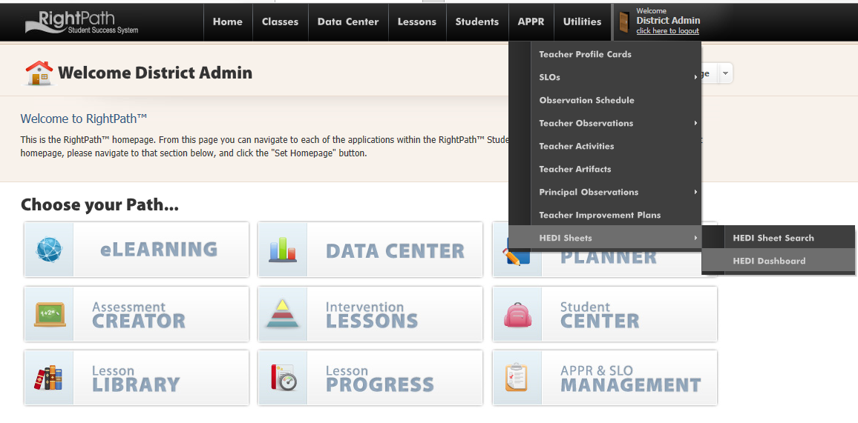
- This will direct you to a page that shows the status of your HEDI Sheets. Click on the blue bar in the graph marked ‘Not Started’ to view the teachers that you need to work on.
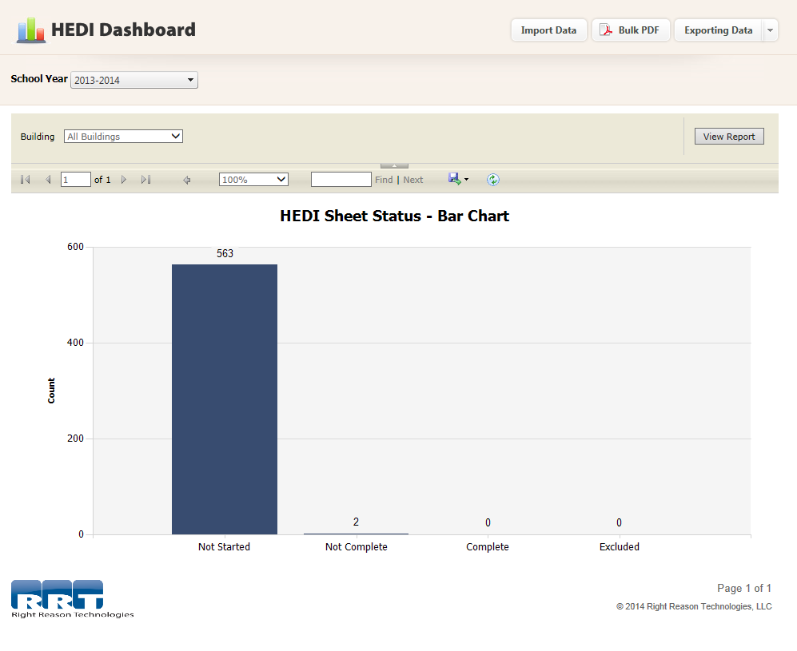
- Click on the teacher’s name to open their HEDI Sheet.

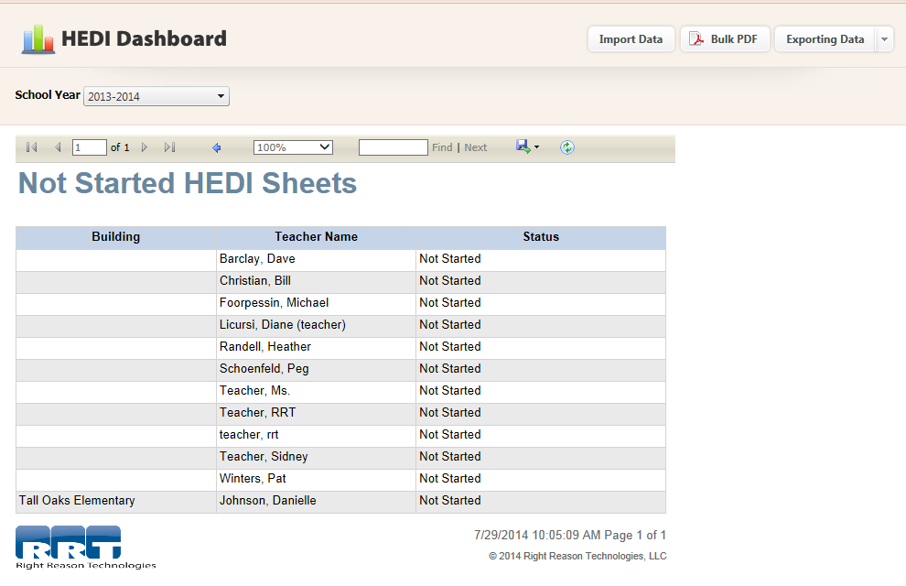

- Enter the scores and click on the ‘Save’ button. Once the HEDI has been saved, you can view the HEDI Rating.
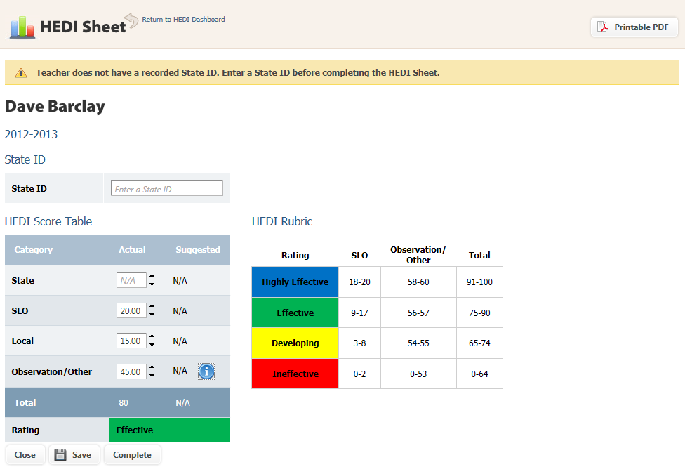
- A message will display at the top to let you know the HEDI Sheet has been saved successfully. Click on the ‘Complete’ button and you will see the confirmation box pop-up. Click on the ‘OK’ button to confirm you are finished entering HEDI Scores for this teacher. Click on the ‘Close’ button to leave this page and return to the HEDI Dashboard Page.

