2014 Student Learning Objectives (SLO) User Guide for Reviewers
RightPath’s™ SLO Goal Form enables users to streamline the creation of the SLO Goal forms and the approval process.
Select Teachers to Review
The RightPath™ SLO system allows administrators the ability to select the teachers that they will be responsible to review. In some districts, this process is predetermined, but in others administrators can select the teachers they are responsible to review.
SLO review selection is accessible from the APPR dropdown menu at the top of any page in RightPath™. To access the platform, go to the ‘APPR’ dropdown menu. From the dropdown list, select ‘SLOs’ and then click on the ‘SLO Reviewees’ option.
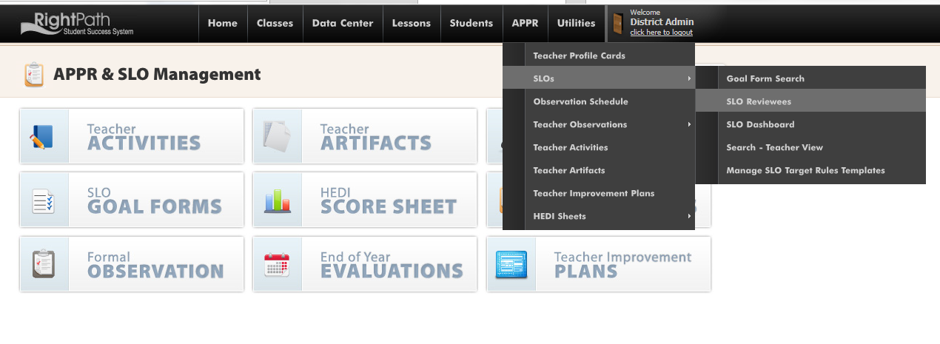

From the SLO Reviewer List page, users can search for an individual teacher, filter by a building, and then click the teacher or teachers’ boxes to add them to his or her review list. Once selections have been made the administrator can click the ‘Add Selected Teachers’ button.

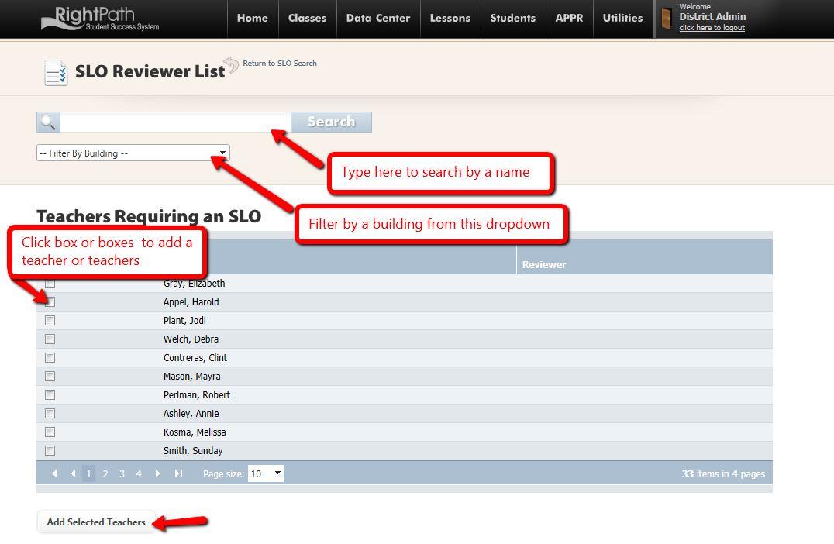

A message will appear to confirm the teacher or teachers have been added. The user can also see the teacher appear in the ‘Your Review List’. In addition, teachers can be removed from the review list by clicking on a teacher’s box and clicking the ‘Remove Selected Teachers’ button.
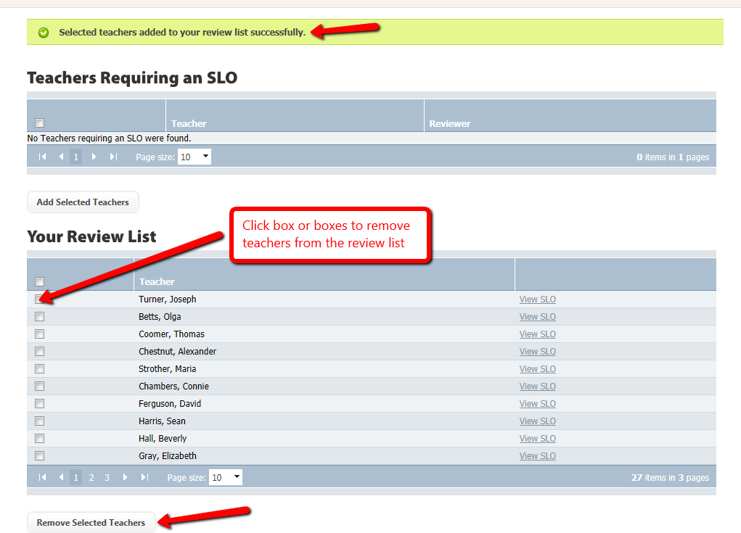

Search the Dashboard
Now that you have your teachers assigned to you, you can search for their SLOs. The SLO Dashboard is accessible from the APPR dropdown menu at the top of any page in RightPath™. To access the platform, click on the ‘APPR’ menu. From the dropdown list, select ‘SLOs’ and then slide over and click on the ‘SLO Dashboard option.
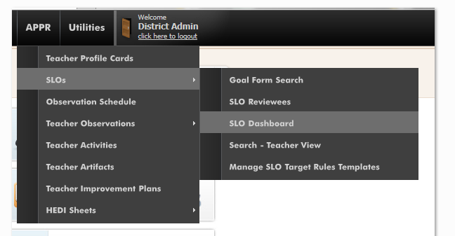

From the SLO Dashboard, you can set the filter to the building and SLO type you want to work on. The only Statuses that you will be able to review are the SLOs listed in the ‘Submitted’, ‘More Information Requested’, ‘End of Year – Submitted’ and ‘End of Year – More Information Requested’ categories. All the categories are described in the Legend below the graph. Click on the blue bar in the grid marked ‘Submitted’ and you will see the list of SLOs ready to be reviewed.

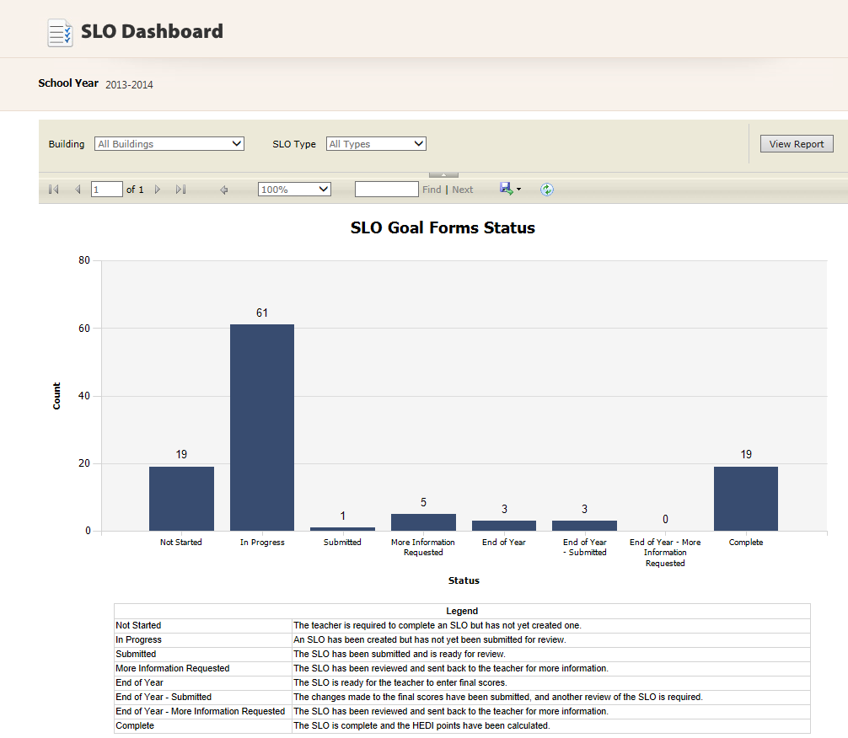

Open the SLO
You will be redirected to the SLO Goal Form Search page. This page can also be accessed by clicking on the ‘APPR’ dropdown menu. From the dropdown list, select ‘SLOs’ and ‘SLO Goal Form Search’. Then use the filters and check boxes on the right side of the screen to see the SLOs that are ready for you to review.
Click on the eye glasses icon to open the Submitted SLO. If you are not able to review the SLO, it may be that you have not been assigned as the reviewer for this teacher.
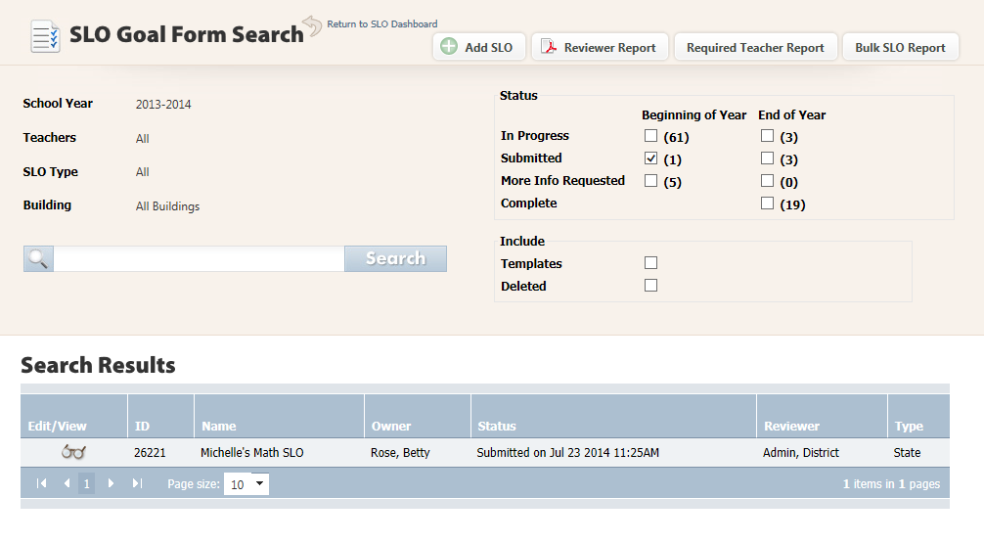
Review the SLO/Check Form
Once the SLO has been opened, it is ready for review. You can click the ‘Check Form’ button at the top of the screen to see any warnings for missing information on this SLO.

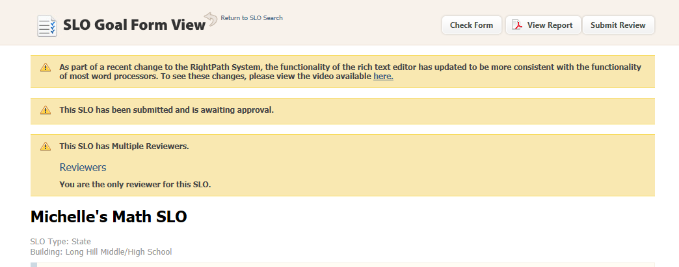
Submit Review (Approve or Reject the SLO)
The Warnings section will show up at the top of the SLO alerting you to missing information. After the SLO has been reviewed, click on the ‘Submit Review’ button to approve or reject the SLO.
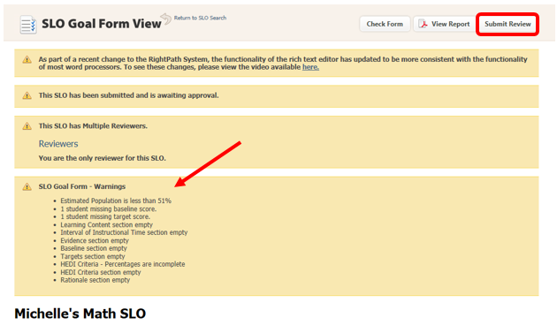
If the reviewer is satisfied with the SLO, he will click the ‘Approve’ button in the pop up box.
If the reviewer is not satisfied with the SLO, he can type comments to the teacher to let them know what needs to be completed. Next, the reviewer will click on the ‘More Information Needed’ button and the SLO will be sent back to the teacher for editing.
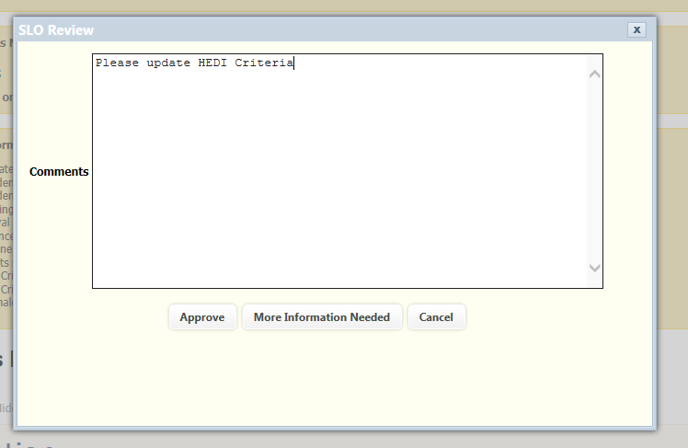
The reviewer’s comments will be visible to the teacher at the top of the SLO when it is opened. The teacher will update the SLO and resubmit it for approval.
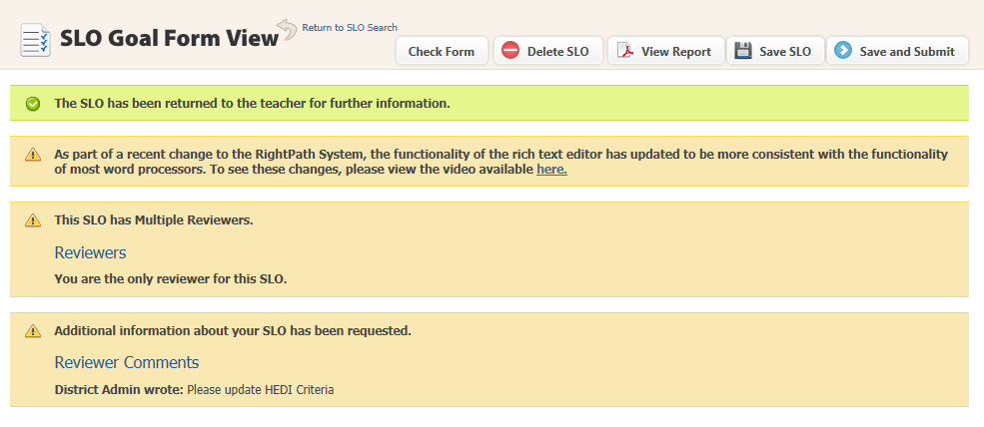
If the SLO is completed satisfactorily this time, the reviewer will click on the ‘Submit Review’ button and choose ‘Approve’. The SLO will move to the End of Year mode for the teachers to add the EOY scores. After the teacher updates the EOY Exam and EOY Scores, the SLO is submitted again. This SLO is now complete and will not be seen by the reviewer again unless it is flagged for review.
An SLO is flagged for a final EOY review if:
There are errors on the SLO.
A student is missing an EOY Score.
A student has been excluded from counting in the SLO calculations (by removing the check mark in the box in the far right column).
Any SLOs that meet the above criteria, need to be reviewed once again before the HEDI score can be calculated.
The approval process will be done the same way once the EOY Scores have been updated. The reviewer will have the choice of clicking on the ‘Approve’ button or the ‘More Information Needed’ button again. Once the SLO is approved for the EOY mode, the HEDI Score will show at the top of the SLO
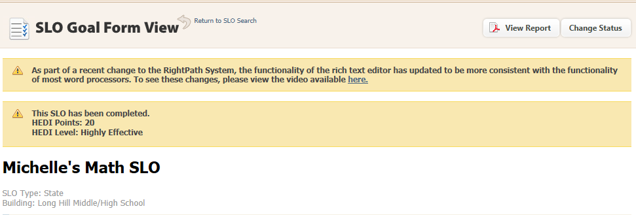
Change Status (Unlock)
If after the SLO was approved or completed and you need to make a change, the reviewer can unlock the SLO by clicking on the ‘Change Status’ button.
A pop up window will display where the reviewer can choose to set the SLO back to ‘In Progress’ mode (to make changes to baseline scores and targets) or ‘End of Year’ mode (to change EOY scores). Next click the ‘Change Status’ (Unlock) button to send the SLO back to the teacher to edit. This SLO will need to be reviewed once again. *Note, when the SLO is set back to ‘In Progress’ mode, the EOY scores will not show up. The scores are still there and will be visible again once the SLO moves to EOY mode.

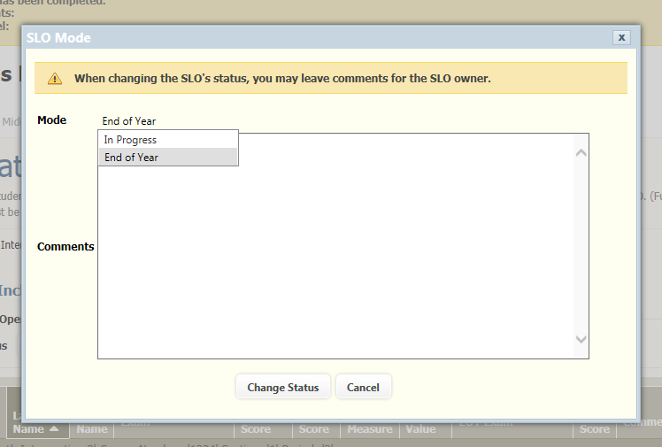
You can check the SLO Goal Form page at any time to see the SLOs that you have left to review. Navigate to APPR>SLOs>Goal Form Search.
Reporting
There are three reports available on the SLO Goal Form Search page, the ‘Reviewer Report’ the ‘Required Teacher Report’, and the ‘Bulk SLO Report’.
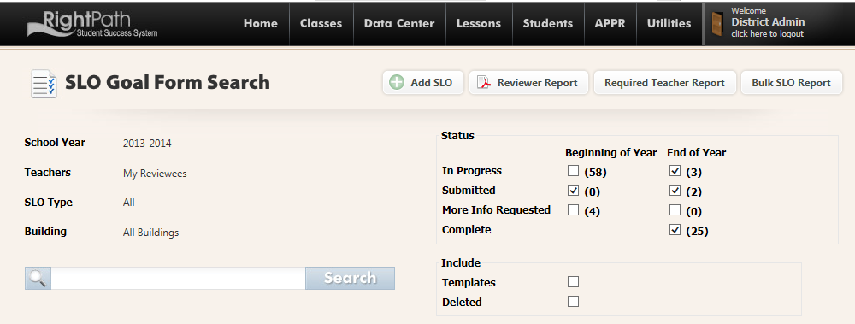

The ‘Reviewer Report’ will generate a list of all the teachers you review and can be filtered by All, State, or Local SLOs.
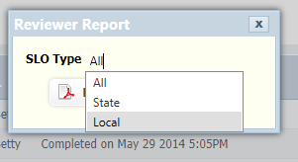

The ‘Required Teacher Report’ will generate a list of all the teachers grouped by reviewer and can be filtered by All, State, or Local.
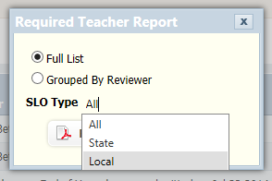

The ‘Bulk SLO Report’ will list every page of every SLO in the selected category.
